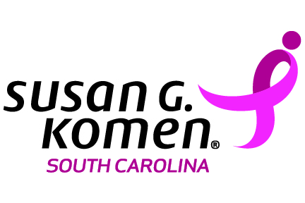
Outreach Request
Mountains to Midlands area
Please submit request at least 6 weeks prior to the date of Event.
All requests must be approved by Komen staff.

Please email the completed form to sandi@komensc.org. Materials for approved requests will be available for pick-up at the affiliate’s Greenville office, located at 82 Orchard Park Rd., Greenville SC. To arrange pick-up, call (864) 234-5035.

Requested by: |  | Phone:
Email Address:
Requesting Organization:
Event Host/Sponsor: |  | Event Date:
Event Location: |  | Event Time:
Event Address:

Request for: Education Materials Only* |  | Presentation |  | Number of attendees
*Many Education materials are available for free downloaded.
Visit http://komensouthcarolina.org/about-breast-cancer/
Is the requesting organization one of the following (mark all that apply):
Non-profit |  | Faith based |  |  |  | Medical Provider |  | State/Federal Agency |  | College/University
current Komen grantee |  |  |  | Other:
Event Type (select one):
Health fair |  | Presentation |  | Lunch & Learn |  | Other
Topics of Interest (select one or more):
Breast health |  |  | Breast Cancer |  |  |  | Survivorship |  | Affiliate Grants |  |  |  |  | Race for the Cure
 | Volunteer Opportunities |  |  |  | Fundraising Opportunities |  |  |  |  |  | Other
Audience (mark all that apply):
Women |  | African-American |  | unemployed |  | Breast cancer survivors
Men |  | Caucasian |  | working |  | co-survivors
Young Adults (18-25 yrs) |  | Hispanic |  | retired |  | general audience
Teens (12-16 yrs) |  | Other |  | Other/Not listed
Purpose of Event:

